Leeds University Business School

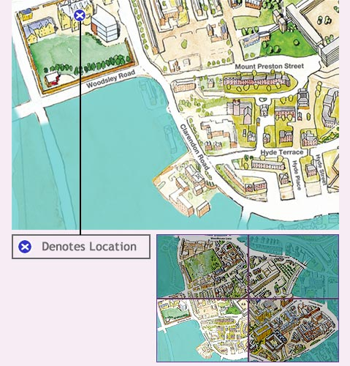

Suggested Routes to Leeds University Business School
From Major Road Networks

From the South (M1 Motorway): At Junction 43 take the M621 towards Leeds. When the M621 splits, take the Manchester exit. *Exit the M621 at junction 2, taking the A643 towards Wetherby. At the first roundabout take the third exit to city centre (A58). Continue on the A58(M) and take the A660 Skipton & Universities exit. Immediately take the left fork (A660), then turn right at traffic lights into Woodhouse Lane. Continue past the University on your left for 0.5 mile, then turn left at the traffic lights into Clarendon Road. Turn right into Moorland Road and the Business School is immediately on your left.

From the West (M62): Exit M62 at junction 27 to the M621. Continue from*

From the East (M62): Exit M62 at junction 29 to the M1 Northbound. Immediately at junction 43 take the M621 towards Leeds. When the M621 splits, take the Manchester exit. Continue from*

From North (A1) and from York: Leave A1 taking A64 towards Leeds and City Centre for several miles. In the City Centre, take exi to Skipton & University A660, which will bring you to Woodhouse Lane. Continue past the University on your left for 0.75 mile, and at the traffic lights turn left into Clarendon Road. Turn right into Moorland Road and the Business School is immediately on your left.

If using a Satellite Navigation System use Postcode LS6 1AN

